Bài 1:
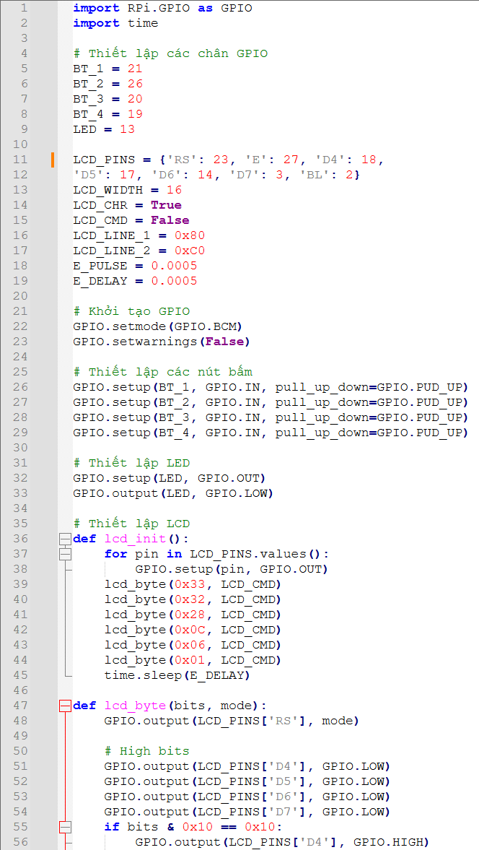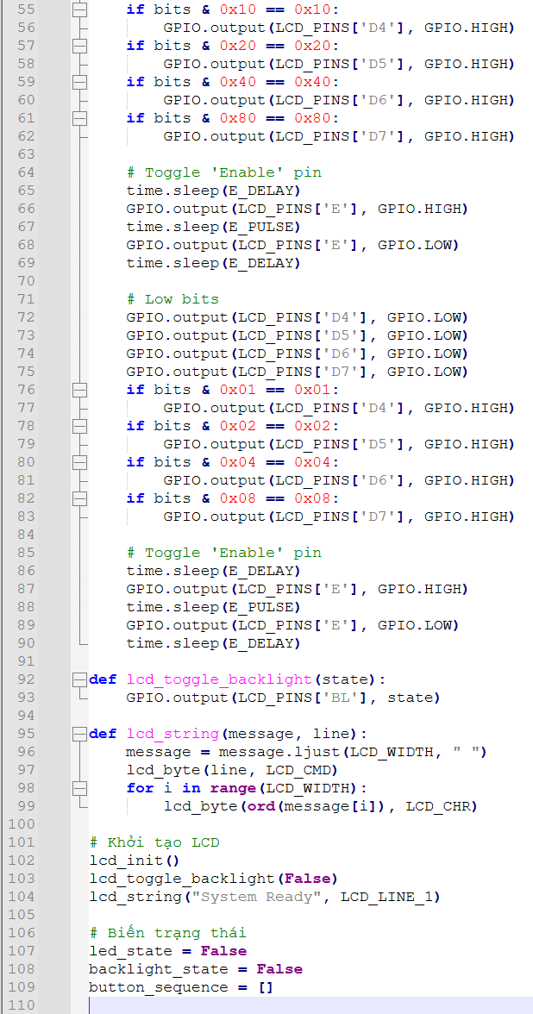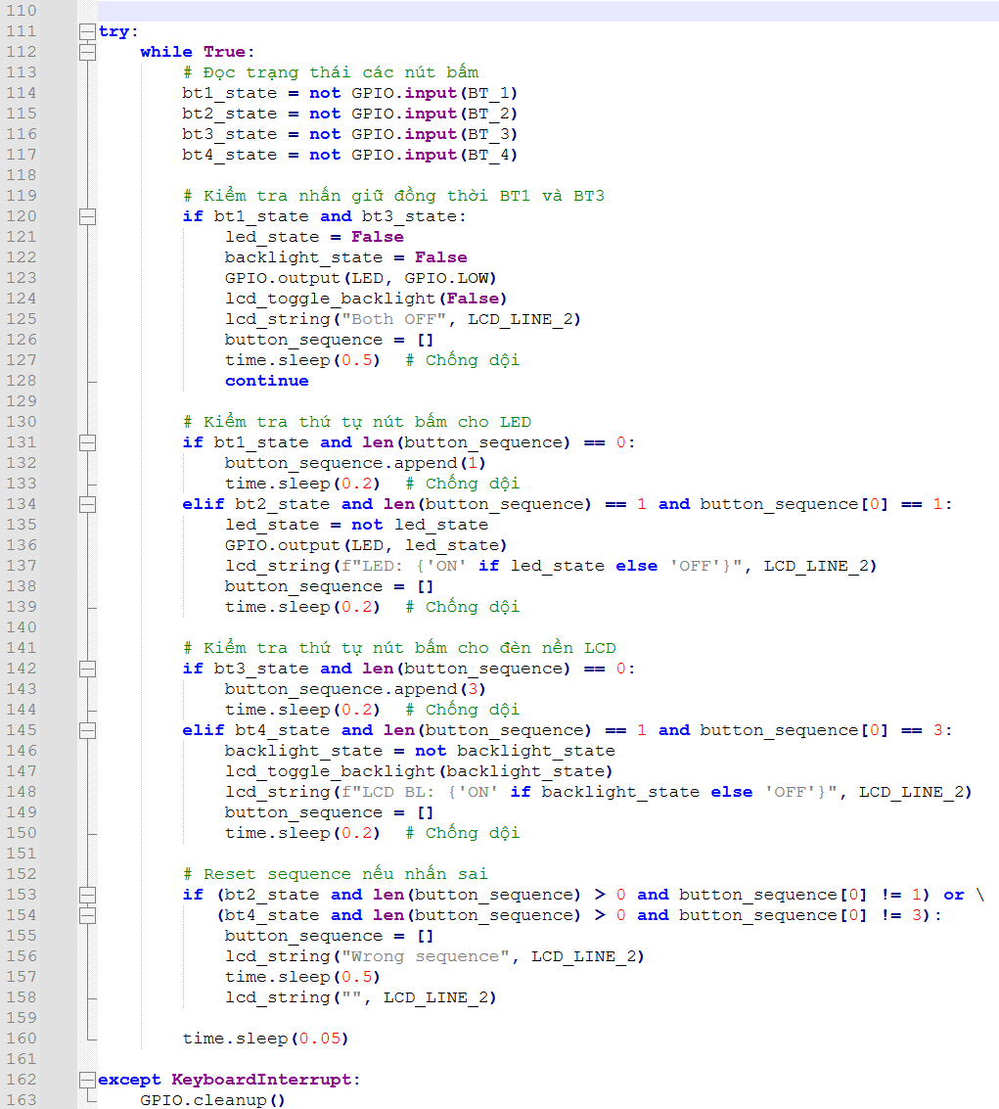

Bài 2:
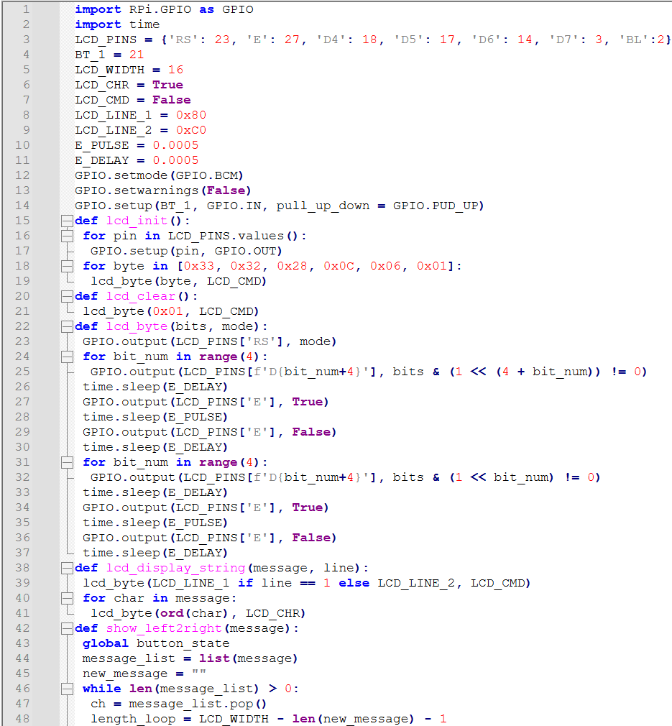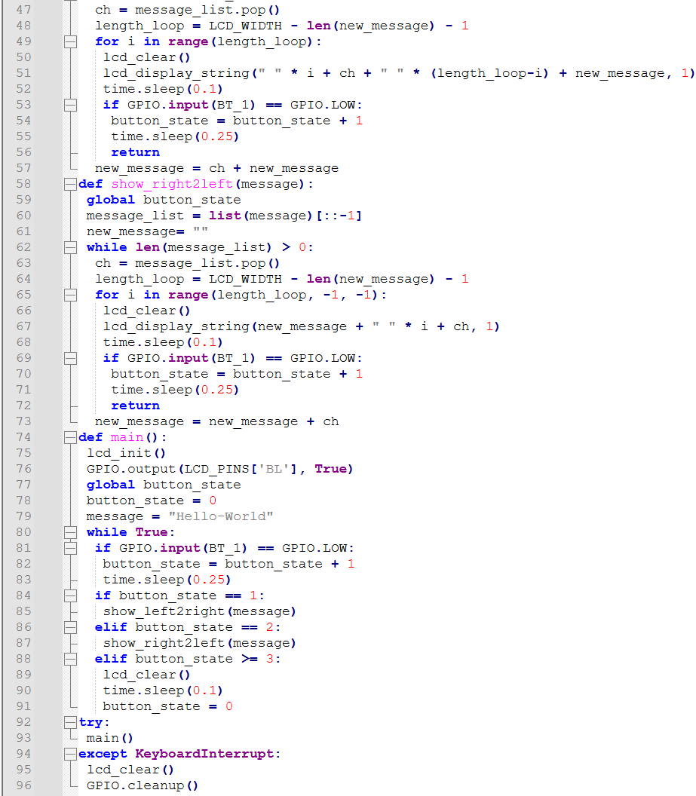

Bài 3:
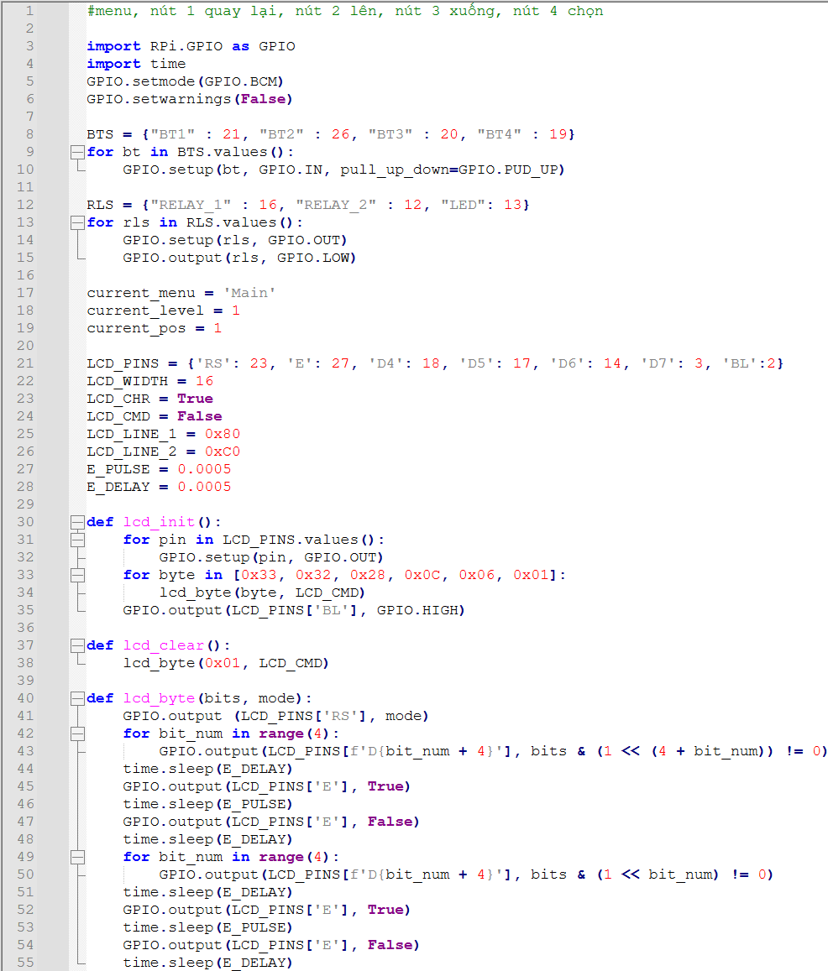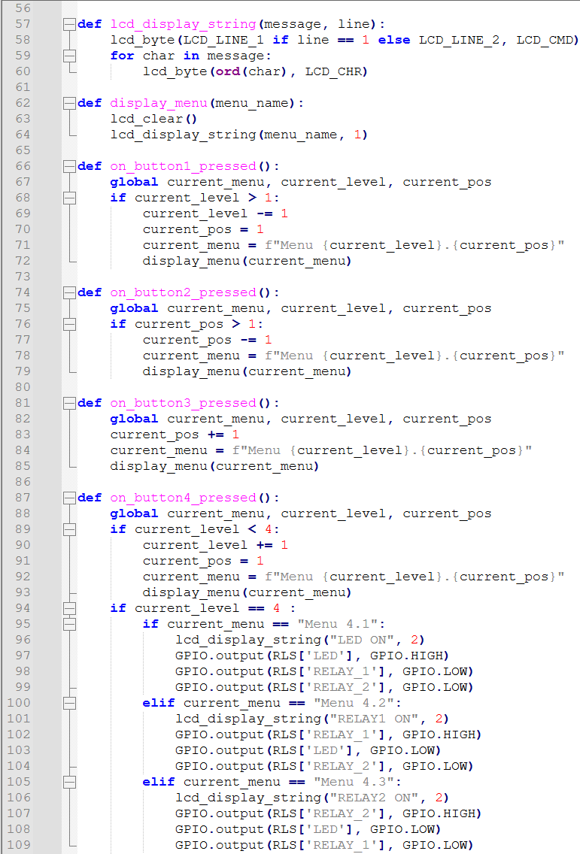
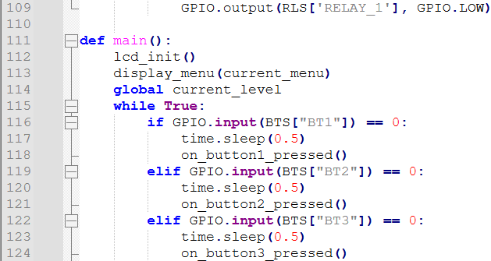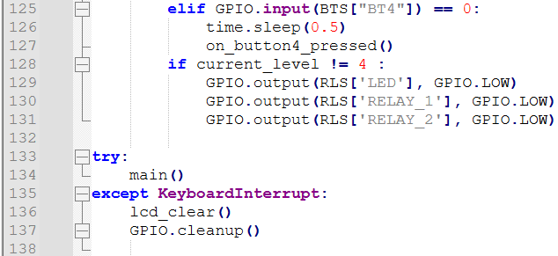
Bài 4: (v1)
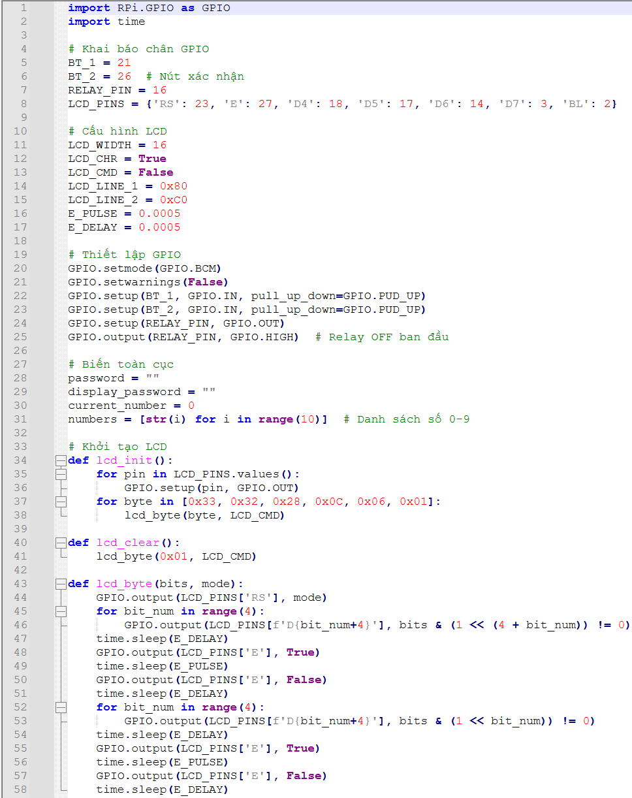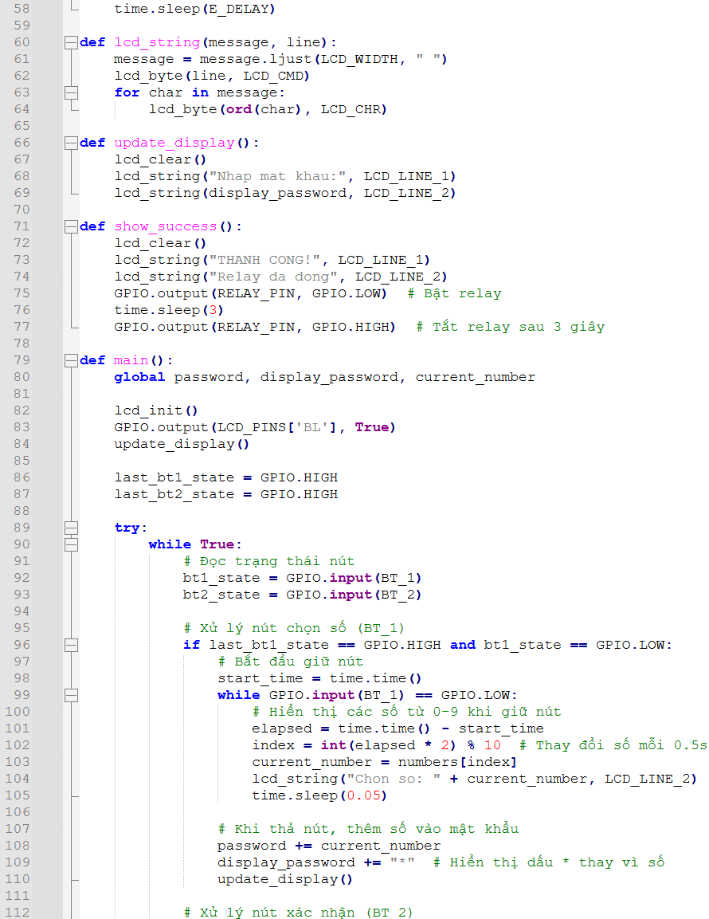
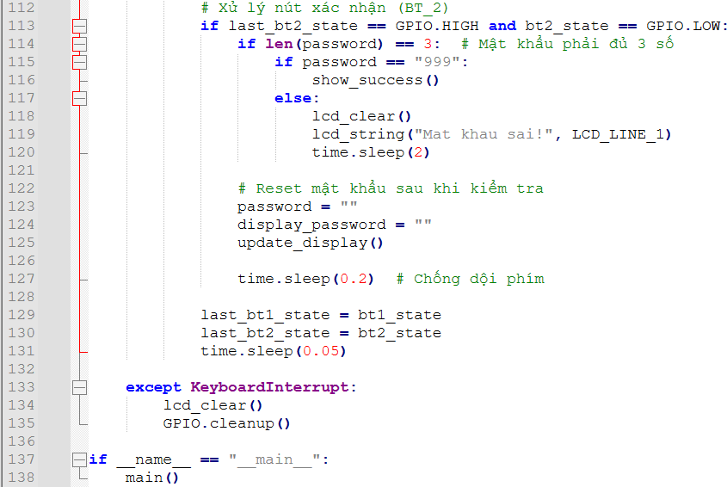
Bài 4: (v2)
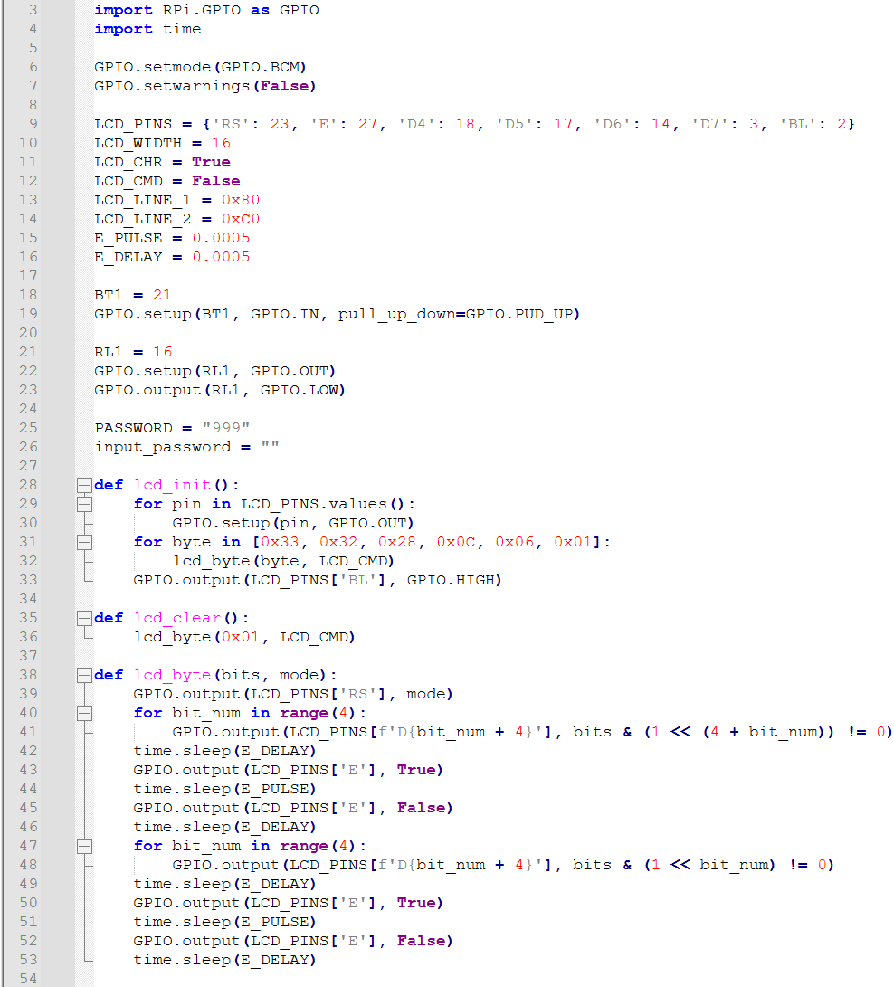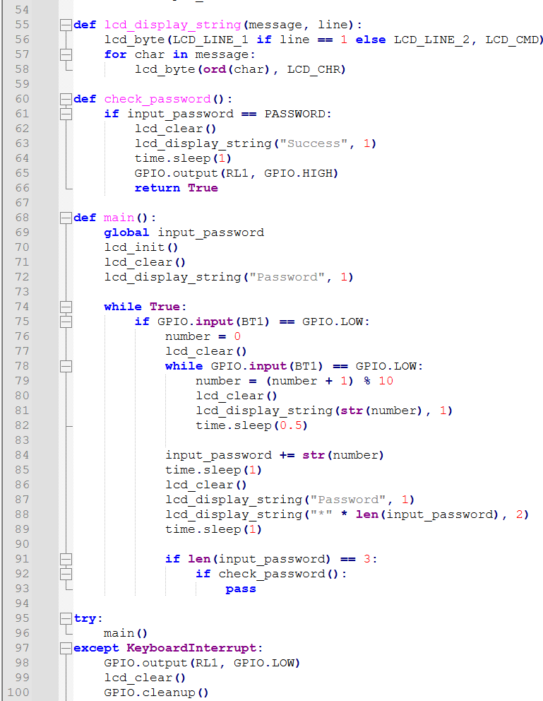

Bài 5:
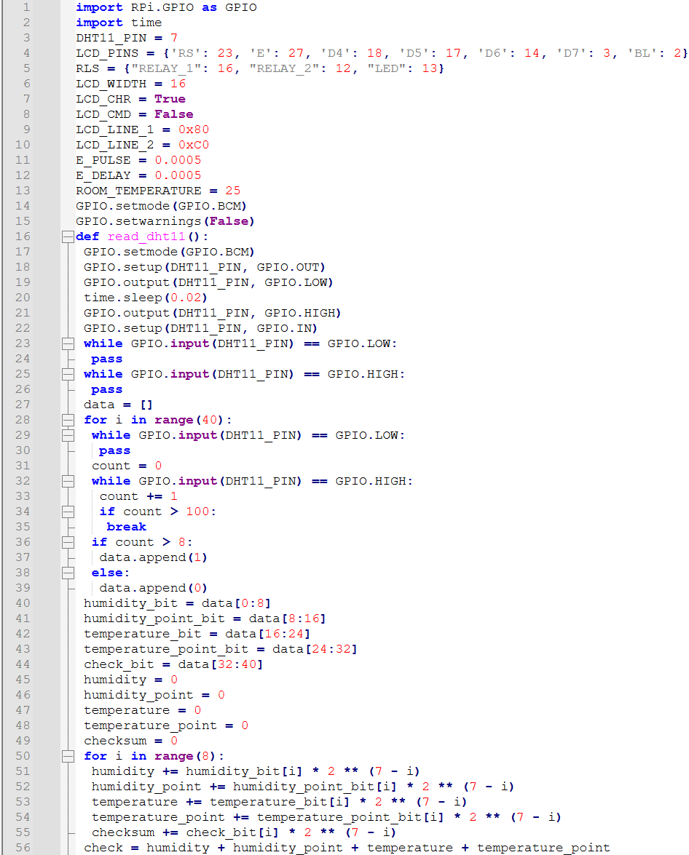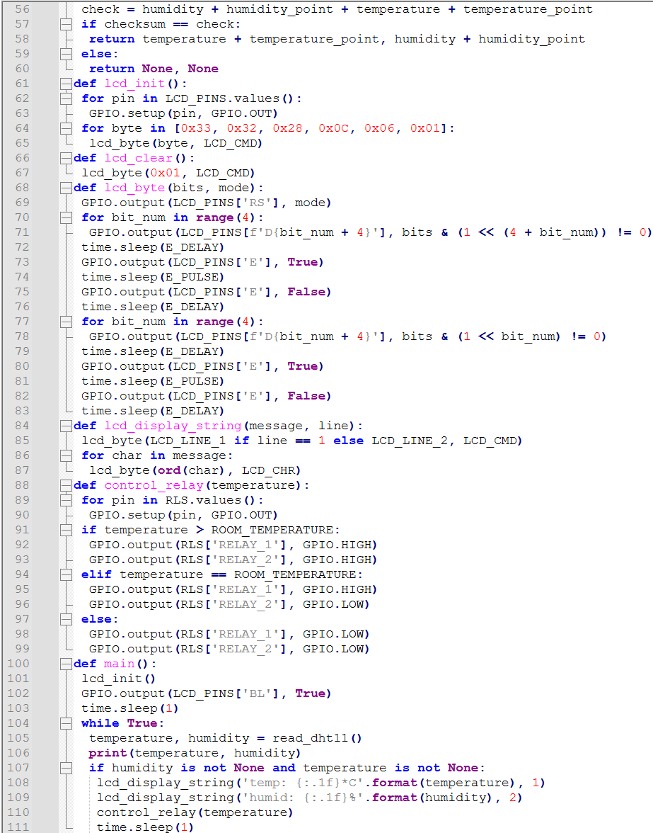
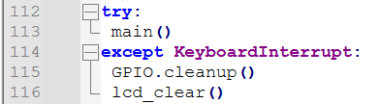
Bài 6:
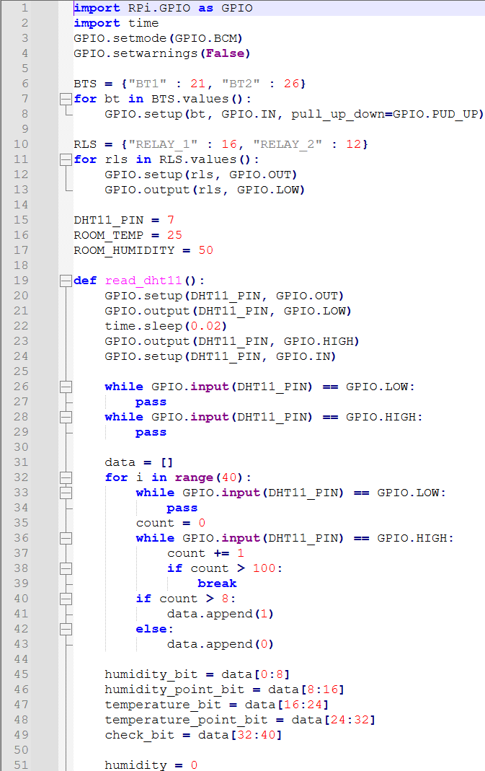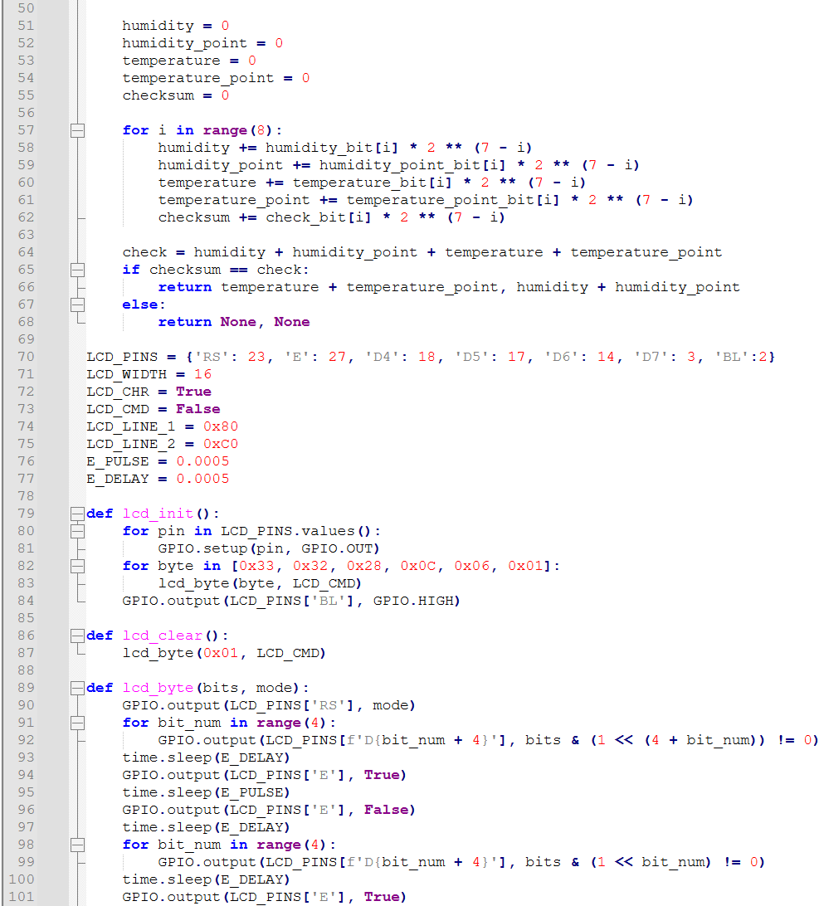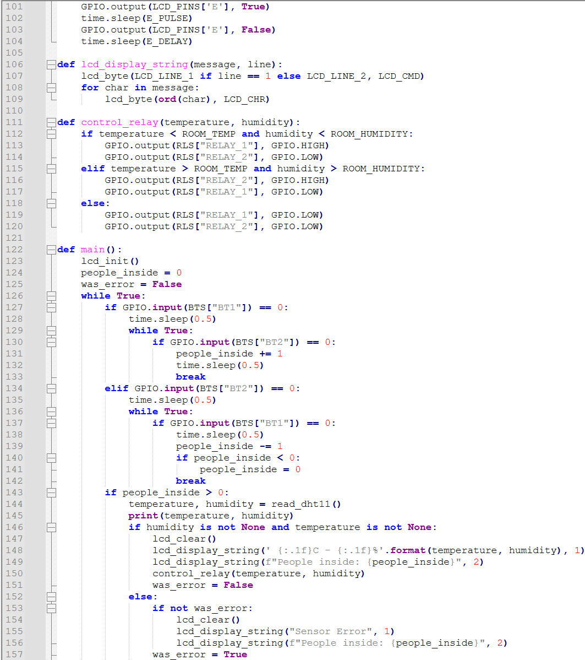
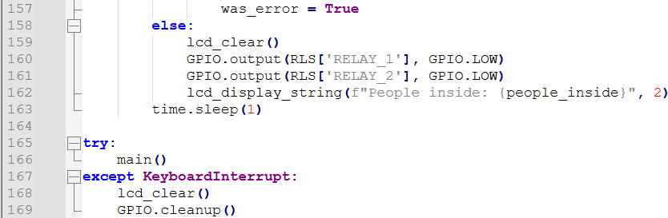
Bài 7:
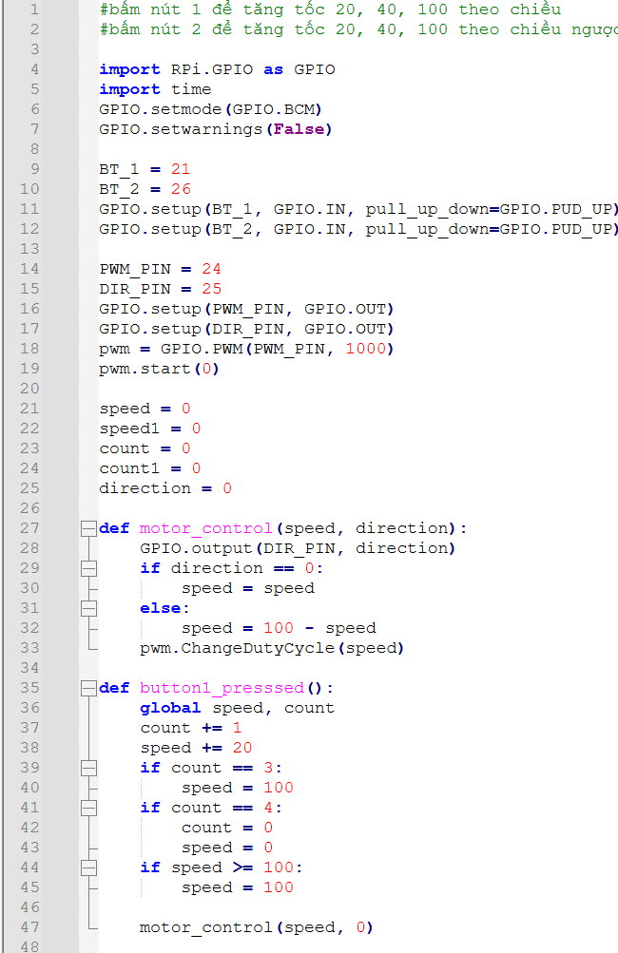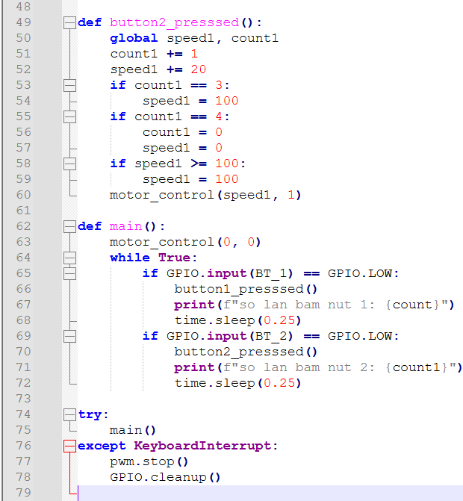

Bài 8:
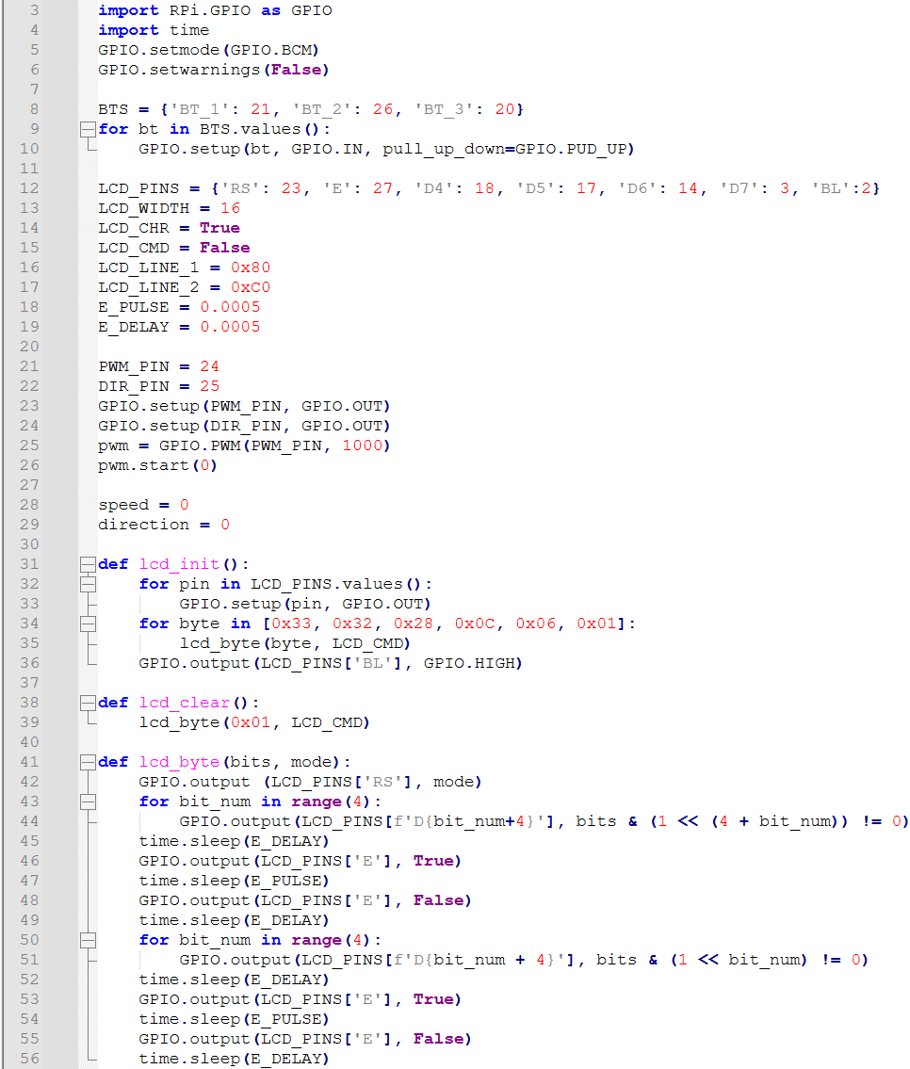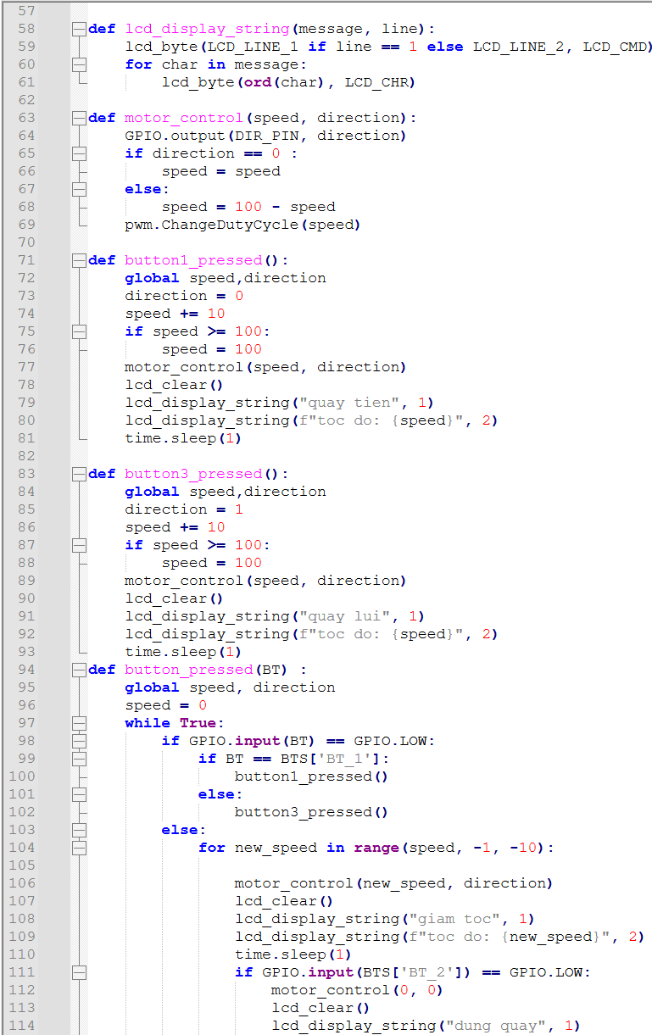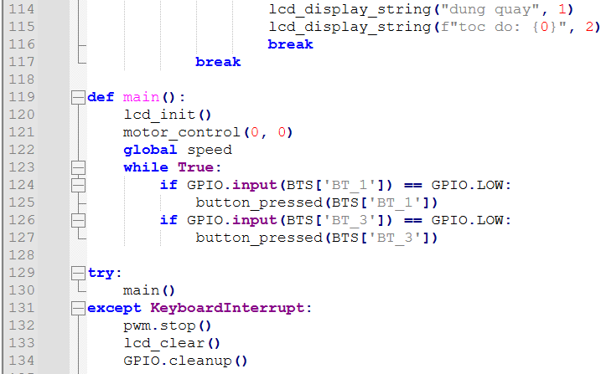
Bài 9:
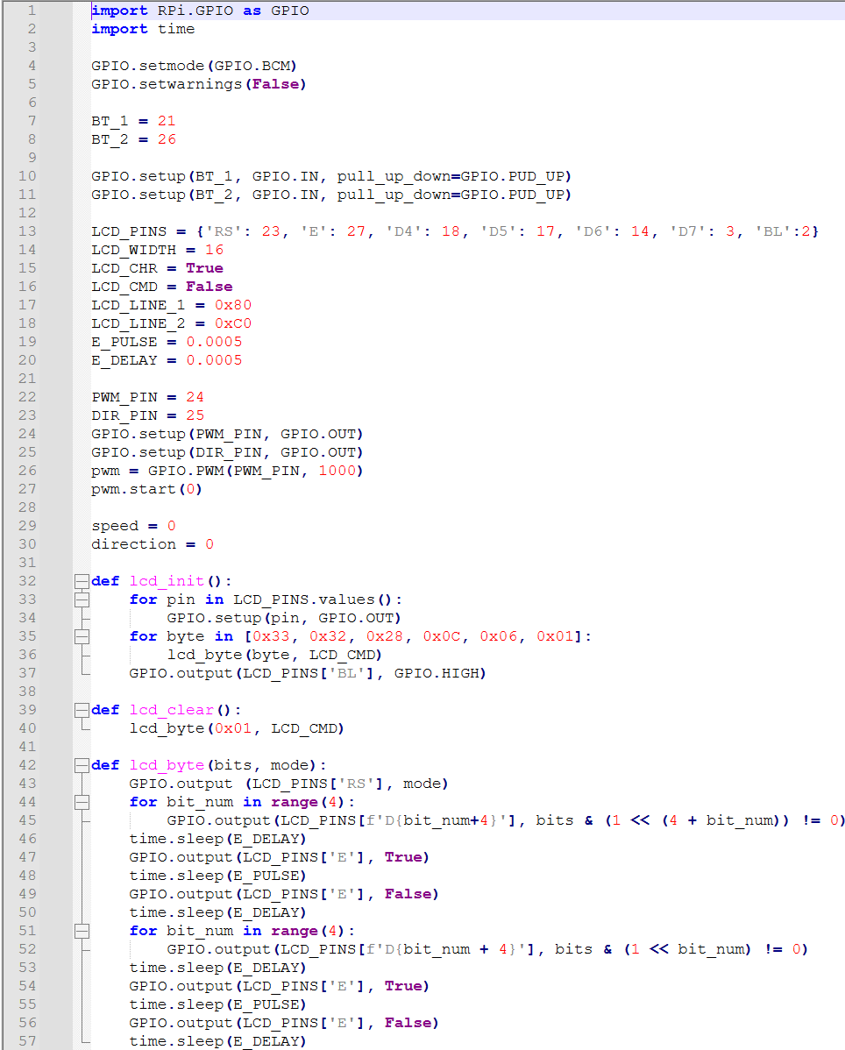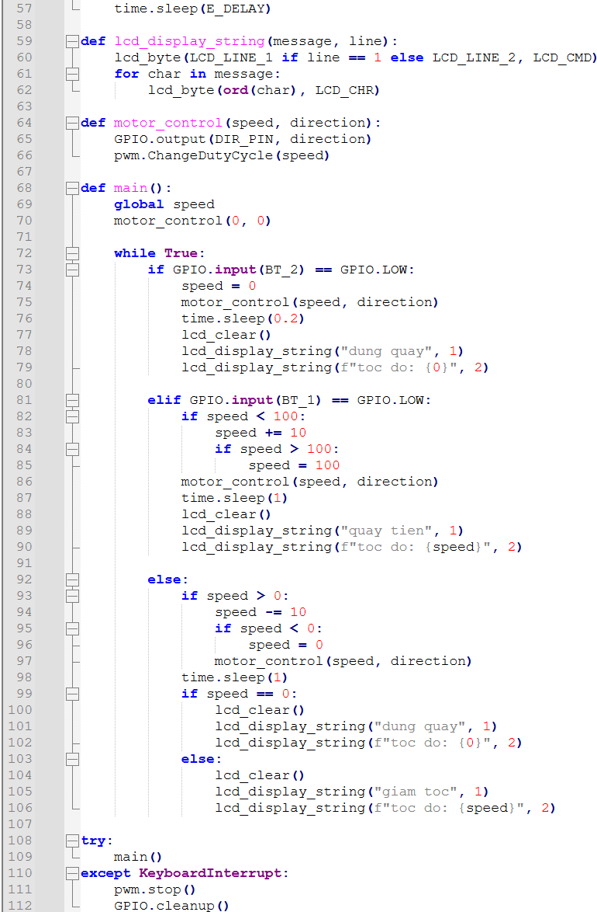

Bài 10:
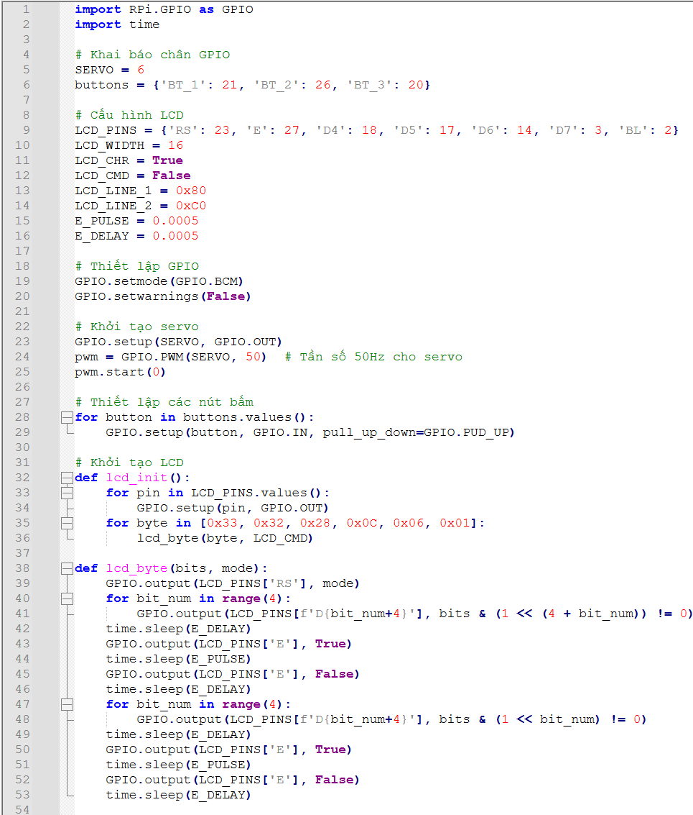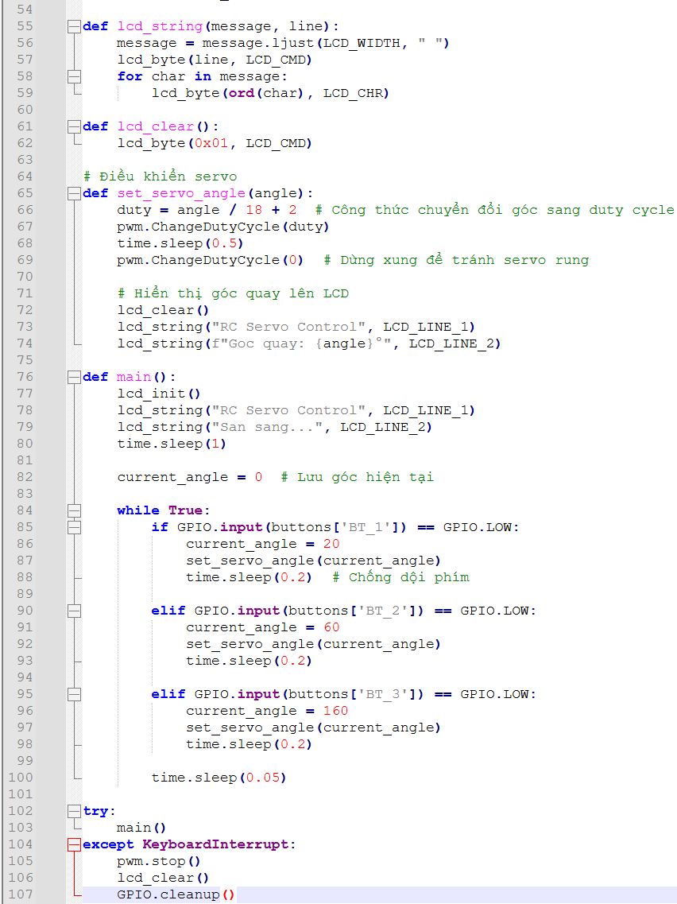

Bài 11:
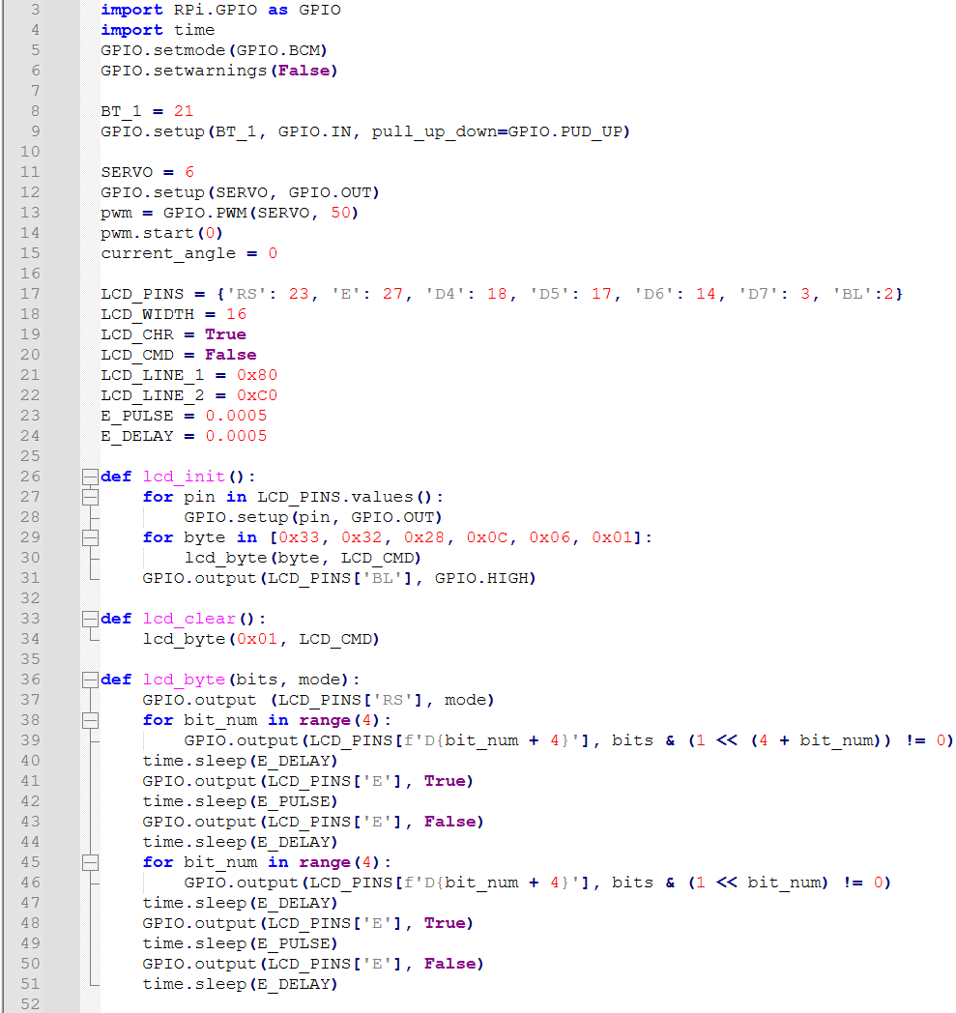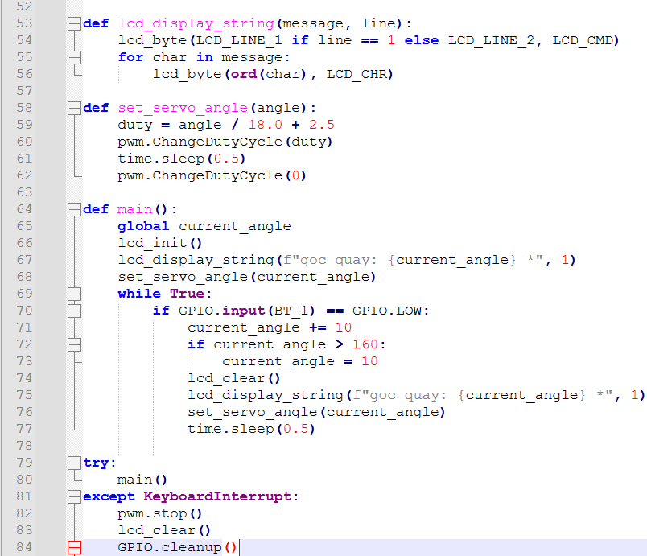

Bài 12:
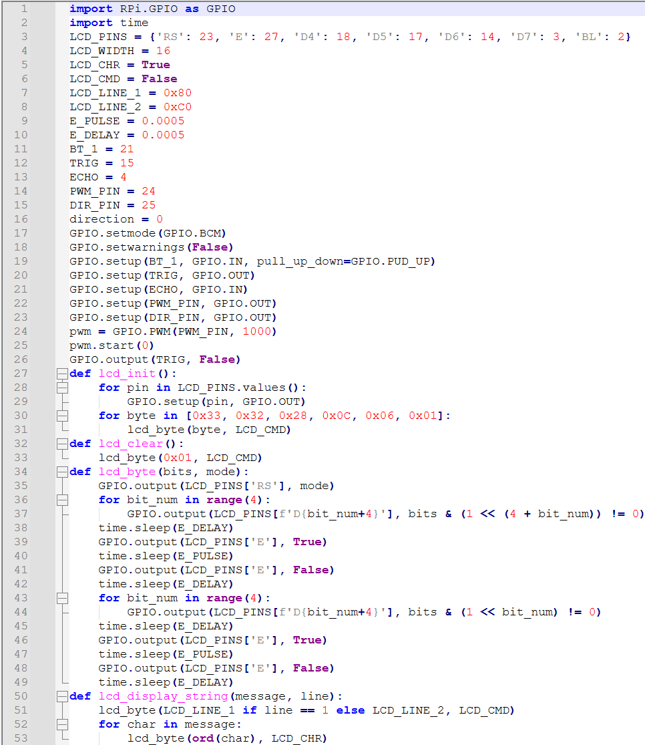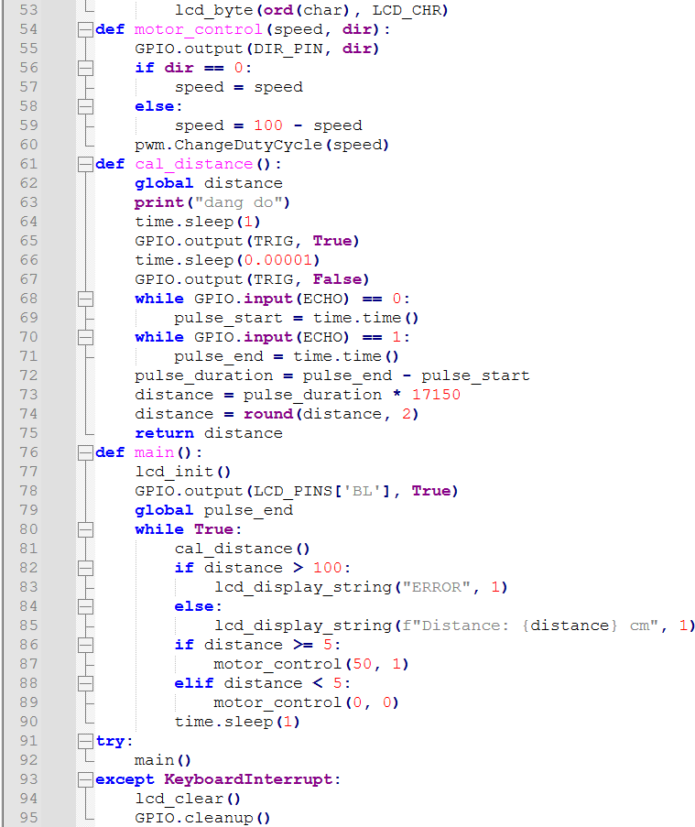

Bài 13:
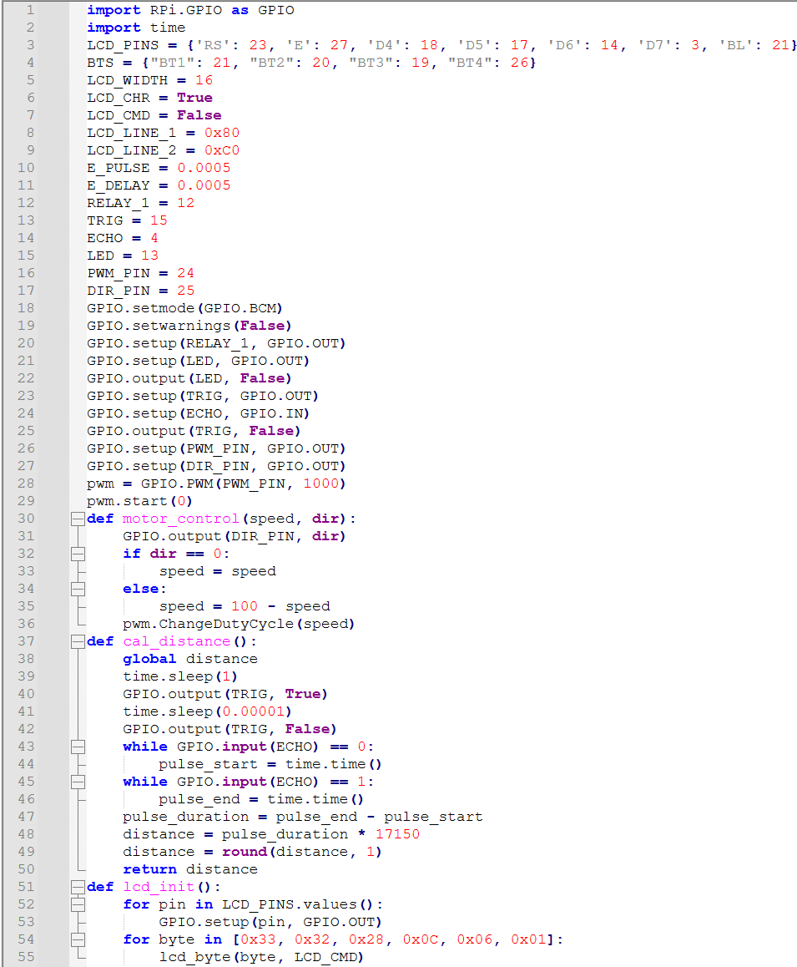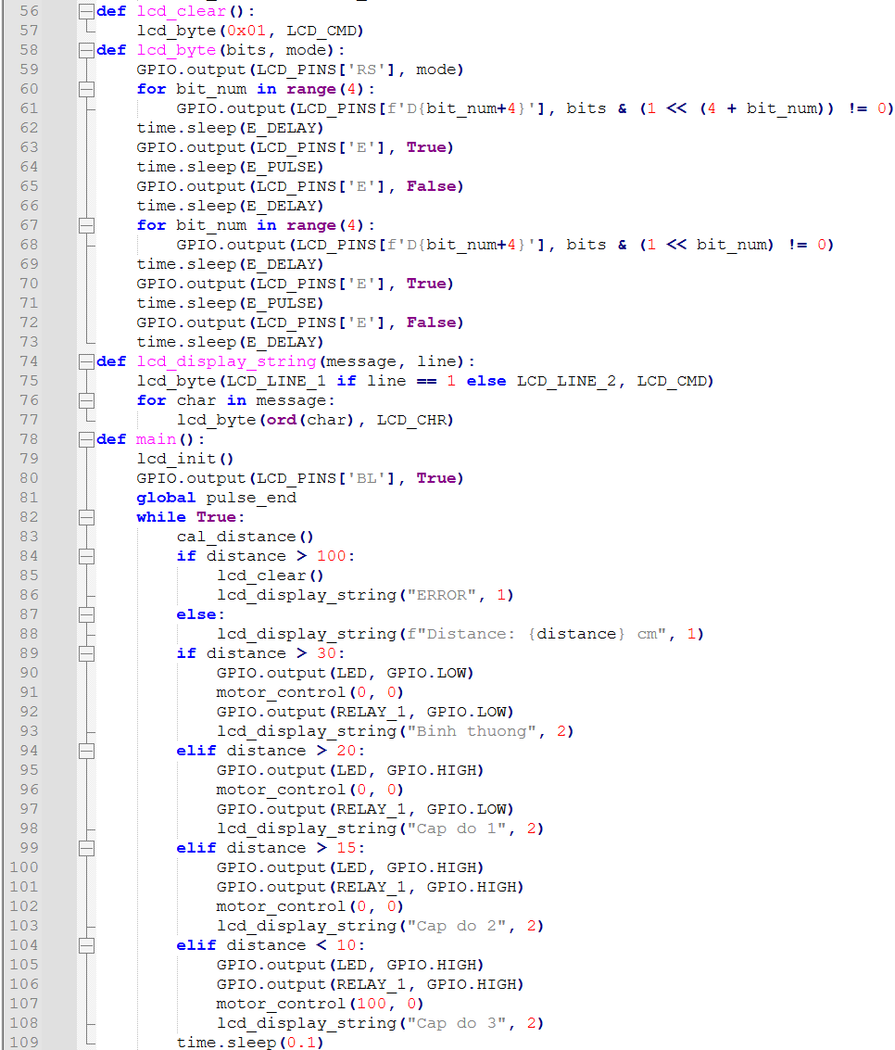
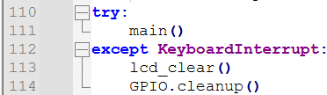
Bài 14:
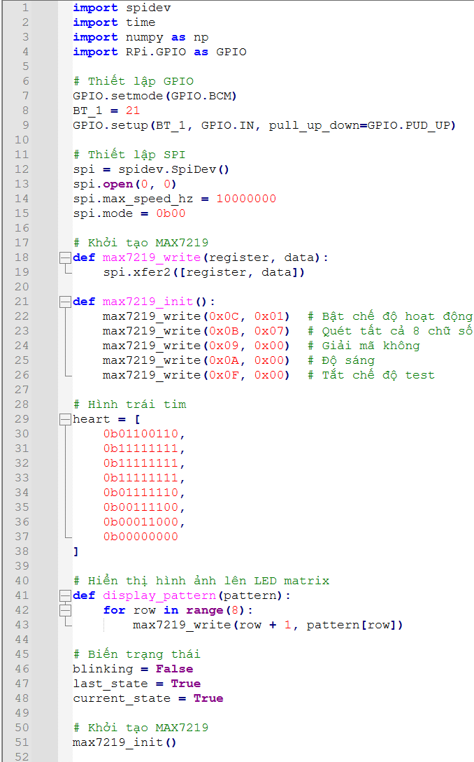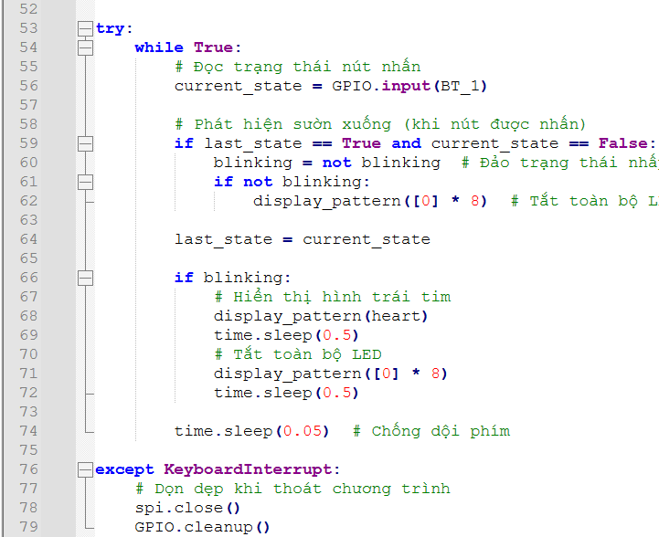

Bài 15:
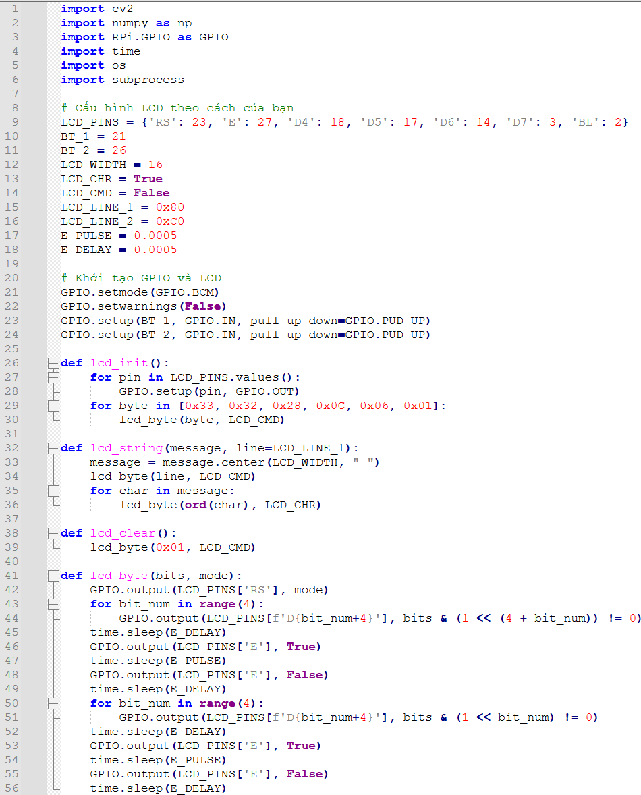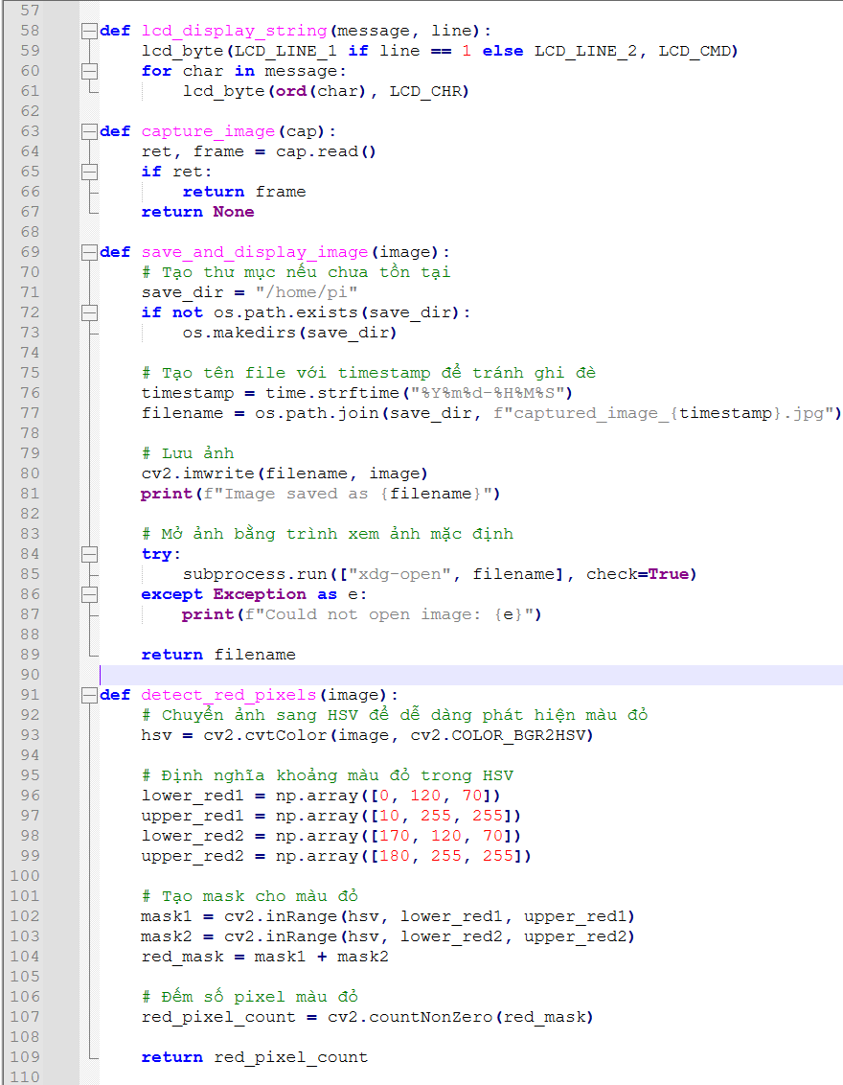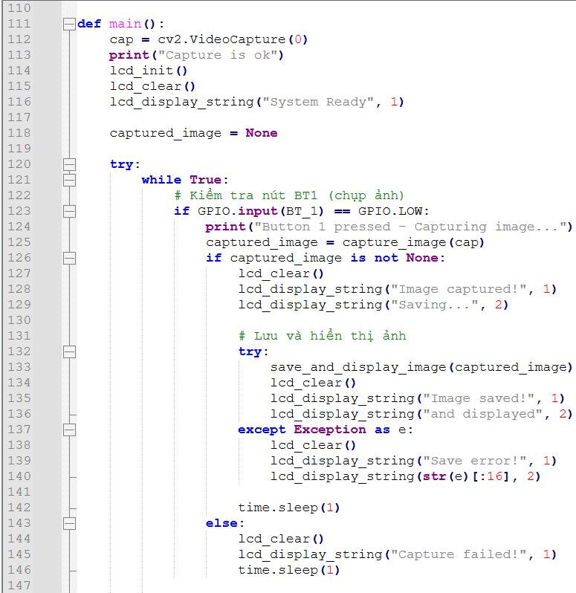
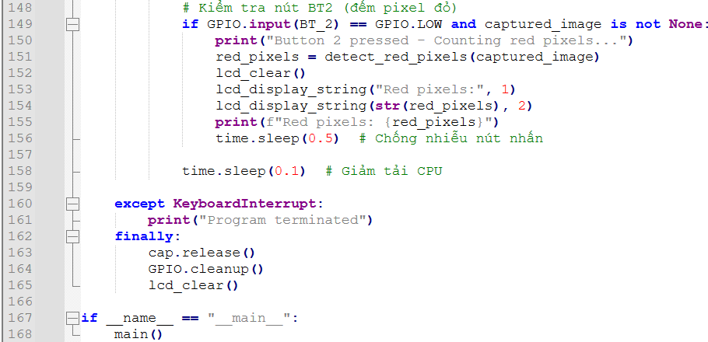
Bài 16:
import cv2  import numpy as np  import RPi.GPIO as GPIO  import time  import os  import subprocess  # Cấu hình LCD  LCD_PINS = {'RS': 23, 'E': 27, 'D4': 18, 'D5': 17, 'D6': 14, 'D7': 3, 'BL': 2}  BT_1 = 21  BT_2 = 26  RELAY_1 = 16 # Chân điều khiển Relay 1  RELAY_2 = 12 # Chân điều khiển Relay 2  LCD_WIDTH = 16  LCD_CHR = True  LCD_CMD = False  LCD_LINE_1 = 0x80  LCD_LINE_2 = 0xC0  E_PULSE = 0.0005  E_DELAY = 0.0005  # Khởi tạo GPIO và LCD  GPIO.setmode(GPIO.BCM)  GPIO.setwarnings(False)  GPIO.setup(BT_1, GPIO.IN, pull_up_down=GPIO.PUD_UP)  GPIO.setup(BT_2, GPIO.IN, pull_up_down=GPIO.PUD_UP)  GPIO.setup(RELAY_1, GPIO.OUT)  GPIO.setup(RELAY_2, GPIO.OUT)  GPIO.output(RELAY_1, GPIO.LOW) # Relay OFF (active HIGH - LOW = OFF)  GPIO.output(RELAY_2, GPIO.LOW) # Relay OFF  def lcd_init():  for pin in LCD_PINS.values():  GPIO.setup(pin, GPIO.OUT)  for byte in [0x33, 0x32, 0x28, 0x0C, 0x06, 0x01]:  lcd_byte(byte, LCD_CMD)  def lcd_string(message, line=LCD_LINE_1):  message = message.center(LCD_WIDTH, " ")  lcd_byte(line, LCD_CMD)  for char in message:  lcd_byte(ord(char), LCD_CHR)  def lcd_clear():  lcd_byte(0x01, LCD_CMD)  def lcd_byte(bits, mode):  GPIO.output(LCD_PINS['RS'], mode)  for bit_num in range(4):  GPIO.output(LCD_PINS[f'D{bit_num+4}'], bits & (1 << (4 + bit_num)) != 0)  time.sleep(E_DELAY)  GPIO.output(LCD_PINS['E'], True)  time.sleep(E_PULSE)  GPIO.output(LCD_PINS['E'], False)  time.sleep(E_DELAY)  for bit_num in range(4):  GPIO.output(LCD_PINS[f'D{bit_num+4}'], bits & (1 << bit_num) != 0)  time.sleep(E_DELAY)  GPIO.output(LCD_PINS['E'], True)  time.sleep(E_PULSE)  GPIO.output(LCD_PINS['E'], False)  time.sleep(E_DELAY) | def lcd_display_string(message, line):  lcd_byte(LCD_LINE_1 if line == 1 else LCD_LINE_2, LCD_CMD)  for char in message:  lcd_byte(ord(char), LCD_CHR)  def capture_image(cap):  ret, frame = cap.read()  if ret:  # Tạo tên file với timestamp để tránh trùng lặp  timestamp = time.strftime("%Y%m%d-%H%M%S")  filename = f"/home/pi/captured_image_{timestamp}.jpg"  cv2.imwrite(filename, frame)  return frame, filename  return None, None  def detect_colors(image):  # Chuyển ảnh sang HSV  hsv = cv2.cvtColor(image, cv2.COLOR_BGR2HSV)  # Định nghĩa khoảng màu đỏ trong HSV  lower_red1 = np.array([0, 120, 70])  upper_red1 = np.array([10, 255, 255])  lower_red2 = np.array([170, 120, 70])  upper_red2 = np.array([180, 255, 255])  # Định nghĩa khoảng màu xanh lá cây trong HSV  lower_green = np.array([35, 50, 50])  upper_green = np.array([85, 255, 255])  # Tạo mask cho màu đỏ  mask_red1 = cv2.inRange(hsv, lower_red1, upper_red1)  mask_red2 = cv2.inRange(hsv, lower_red2, upper_red2)  red_mask = mask_red1 + mask_red2  # Tạo mask cho màu xanh lá cây  green_mask = cv2.inRange(hsv, lower_green, upper_green)  # Đếm số pixel  red_pixels = cv2.countNonZero(red_mask)  green_pixels = cv2.countNonZero(green_mask)  return red_pixels, green_pixels  def control_relays(red_pixels, green_pixels):  if red_pixels > green_pixels:  GPIO.output(RELAY_1, GPIO.HIGH) # Bật Relay 1 (active HIGH)  GPIO.output(RELAY_2, GPIO.LOW) # Tắt Relay 2  return "RED > GREEN", 1  else:  GPIO.output(RELAY_1, GPIO.LOW) # Tắt Relay 1  GPIO.output(RELAY_2, GPIO.HIGH) # Bật Relay 2  return "GREEN >= RED", 2  def show_image(filename):  try:  # Mở ảnh bằng trình xem ảnh mặc định trên Raspberry Pi  subprocess.run(["xdg-open", filename])  except Exception as e:  print(f"Error opening image: {e}") | def main():  cap = cv2.VideoCapture(0)  print("Capture is ok")  lcd_init()  lcd_clear()  lcd_display_string("System Ready", 1)  captured_image = None  last_image_path = None  try:  while True:  # Kiểm tra nút BT1 (chụp ảnh)  if GPIO.input(BT_1) == GPIO.LOW:  print("Button 1 pressed - Capturing image...")  captured_image, image_path = capture_image(cap)  if captured_image is not None:  lcd_clear()  lcd_display_string("Image captured!", 1)  lcd_display_string("Saving...", 2)  last_image_path = image_path  time.sleep(1)  # Hiển thị ảnh vừa chụp  lcd_clear()  lcd_display_string("Showing image...", 1)  show_image(image_path)  time.sleep(1)  else:  lcd_clear()  lcd_display_string("Capture failed!", 1)  time.sleep(1)  # Kiểm tra nút BT2 (đếm pixel và điều khiển relay)  if GPIO.input(BT_2) == GPIO.LOW and captured_image is not None:  print("Button 2 pressed - Processing image...")  red_pixels, green_pixels = detect_colors(captured_image)  result, relay_state = control_relays(red_pixels, green_pixels)  lcd_clear()  lcd_display_string(f"R:{red_pixels} G:{green_pixels}", 1)  lcd_display_string(result, 2)  print(f"Red pixels: {red_pixels}, Green pixels: {green_pixels}")  print(f"Relay {relay_state} activated")  time.sleep(0.5) # Chống nhiễu nút nhấn  time.sleep(0.1) # Giảm tải CPU  except KeyboardInterrupt:  print("Program terminated")  finally:  cap.release()  GPIO.output(RELAY_1, GPIO.LOW) # Tắt Relay khi kết thúc  GPIO.output(RELAY_2, GPIO.LOW) # Tắt Relay khi kết thúc  GPIO.cleanup()  lcd_clear()  if __name__ == "__main__":  main()

